Week 22 Report
Last week we assigned sections of the V&V report to each person in the group. This week we met to go over what we had written and work to answer any questions.

Last week we began working with the thermoplastic casting material to create a prototype torso support. We used 3 packages of casting material and wrapped it around a pillow covered in duct tape that was approximately the size of the child. After it set, we cut it down the side to remove it from the pillow and were left with this shape. The sides of the casted shape are too high and too wide, but it was a good first attempt.

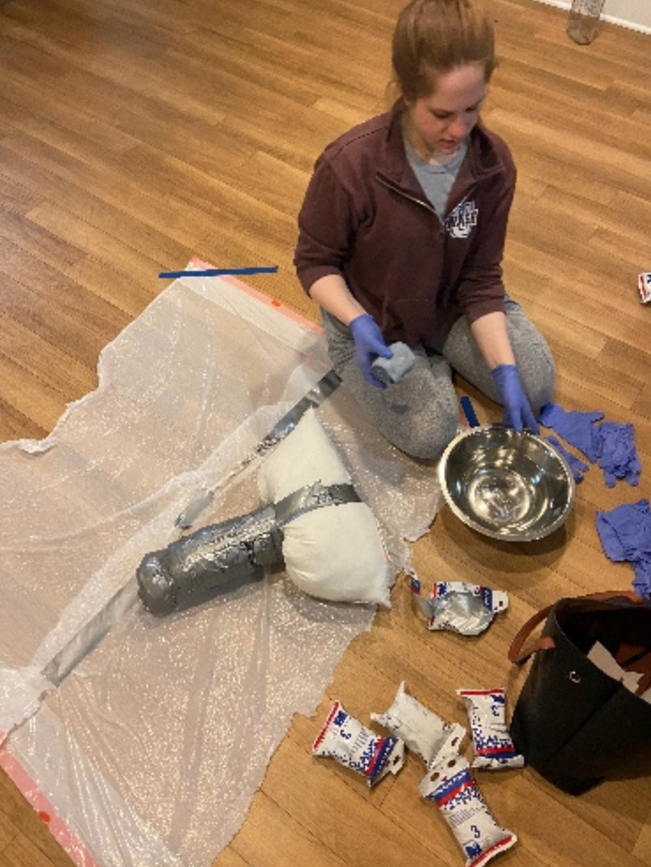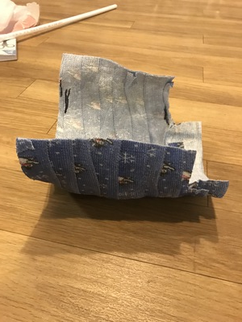

We also performed tension testing on the PEX pipe in the lab. Loading it with 215 N then 228 N, we tested to ensure that the pipe maintained its original shape after loading and unloading. Thus, we believe the PEX pipe will provide the base for the spring tilt functionality of the device.

